# Mtp experience:

HazelnutFSPM. This is the Ph.D. project of Francesca.

Contents

Mtp experience: 1

GOALS 1

HAZELNUT DESCRIPTION 3

METHODS 3

Procedures: 4

Exploratory analysis 4

Glms/Markovian 16

FSPM 16

## GOALS

The model of my dreams should answer those questions:

1. How 1 year old shoot is composed?
   * There are some zones of the same type of bud?
   * There are differences in the composition according to the length of the shoot?
2. What is the behavior of lateral shoots?
   * How many of them developed?
   * Where?
   * From which bud? (vegetative or mixed?)
3. How can we deal with multiple buds and multiple lateral shoots per node?

These problems could be solved by analysing the data:

* From a different point of views
  + Shoot scale
  + Metamer scale
  + Bud scale
* With different tecniques:
  + exploratory analysis
  + Glms
  + Markovian models

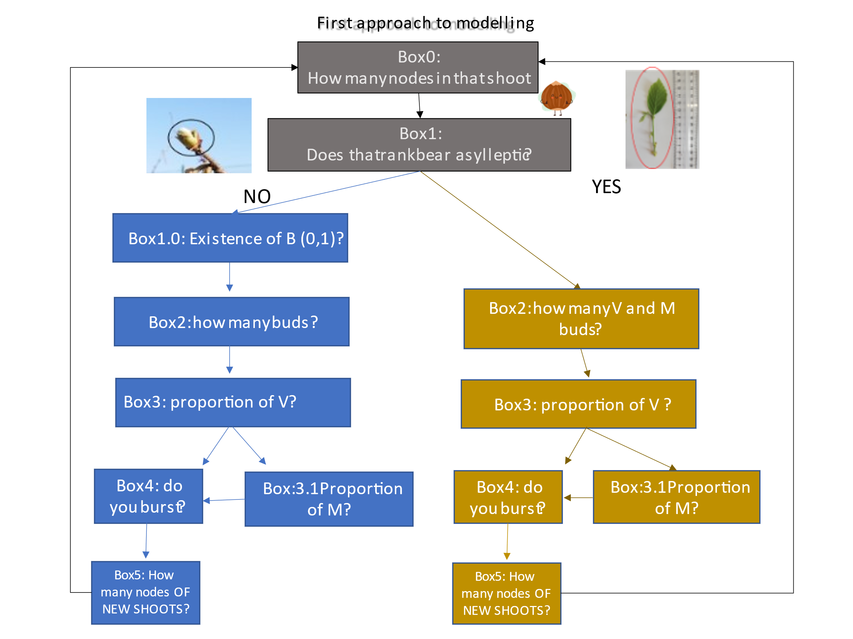Fig. 1: logical diagram of the model

## HAZELNUT DESCRIPTION

* bushy plants;
* 4 types of buds:
  + M: mixed buds. they are preformed buds that during the season develop into a little shoot with at the end the nut;
  + C: catkins (male flower). they are at the top of sylleptic shoots.
  + B: blind nodes;
  + V: vegetative buds. they develop into shoots
* 4 types of shoots:
  + Proleptic (developed in year n)
  + Sylleptic (developed in year n)

## METHODS

A sampling of **240** 1year old shoots (120 from own-rooted plants; and 120 from grafted ones):

* In 2020:
  + Biometric measures at shoot level (diameter, length, number of nodes) of 1-year-old shoots (parent);
  + Qualitative measures at node level (type of bud/sylleptic (M= mixed, C=catkin, V=vegetative, B=blind) of the same 1-year-old shoots
* In 2021:
  + Biometric measures at shoot level (diameter, length, number of nodes) of 1-year-old shoots (child) born from the parent;
  + Qualitative measures at node level (type of bud/sylleptic (M= mixed, C=catkin, V=vegetative, B=blind) of the same child shoots

WE WILL FOCUS JUST ON OWN-ROOTED PLANTS

## Procedures:

1. Exploratory analysis
2. Glms/markovian
3. FSPM

### Exploratory analysis

1. The first problem we met (Evelyne, Fred, and JB) was the **definition of concepts.** While I was explaining how the hazelnut architecture is composed we had to fix the same language for everyone. To avoid misunderstandings. In particular: buds, rank, parent shoot, lateral shoots, apical shoots, branching pattern, succession, proleptic and sylleptic shoot, metamer scale, shoot scale, bud scale, multiple buds.

This was crucial to let everyone understand what I was doing.

1. The second problem was regarding the **data frames layout** it should be as comprehensible as possible, avoiding using the same name for different things in different data frames.
2. The third problem regarded the apical buds: some terminal nodes in our recordings were sylleptic shoots. But we cannot highlight a SYLLEPTIC SHOOT as TERMINAL BUD, thus, I modified manually the df to extract the apical bud from those sylleptic. Then I put the apical in a different node from sylleptic.

This simplifies the computation in RSTUDIO and makes the script understandable by everyone.

Exploratory analysis was done as follow:

1. Annual shoot;
2. Apical buds;
3. Lateral buds;

#### Annual shoot

**120** annual shoots (Fig. 2) were selected in winter 2020, in Deruta, choosing 30 shoots for each length class (Table. 1a). and biometrical measurements, as well as buds recording at each node, was done. We assumed that all of annual shoots were proleptic shoots developed in year n. (Fig. 2)

Fig. 2: graphical representation of 5 annual shoots selected in 2020. The black line is the 2-year-old shoot developed in year n-1. Blu lines are proleptic shoots (the **annual shoots we selected)** developed in year n. Yellow lines are sylleptic shoots developed, in some ranks of the proleptic, in year n.

At the **annual shoot scale (fig2)**, in 2020, four length categories (**called: CLASS)** were considered (Table 1a). Observations concerning the type of axillary formation (vegetative buds, reproductive buds - catkins and mixed buds - or blind)  at each node were recorded (Table1b).

Table1: a (left) and b (right)

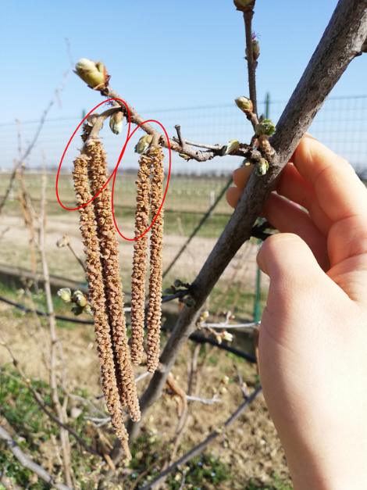NB_ in winter 2020 we did not know that hazelnut had sylleptic shoots. Indeed, because sylleptics **always bear catkins (male flowers)** and because **their internodes were short**, we recorded them as catkins. Later in 2021, when we defined that catkins (and buds near them that we recorded in 2020) are in the sylleptic shoot (Fig. 3) we separated them from the proleptic!!

Figure 3: the photography of catkins in the sylleptic shoot.

|  |  |
| --- | --- |
| **Description of annual shoots that were found also in 2021 (second year of observations)** | |
| TOTAL number of annual shoots (year n) | 104 |
| How many for each class? | 26Sh, 25Me, 28Lo, 25VLo |
| How many buds? (apical + lateral) | 1667 |
| How many children? (apicals + laterals) | 988 |

Table2: an overview of annual shoot data

**NB_ ALL THE ANALYSIS WILL BE DONE ON THOSE 104 SHOOTS!!!**

Question1: What is the distribution of length in the shoot?

We do not have this information because we did not sample randomly but we sampled 20 shoots per category. Anyway we decided to test using R. (Fig. 4)

Fig.4: number of shoots for each annual shoot length. Performed in the annual shoot of year n

From this graph, we can think about making just 2 class lengths merging Sh with Me and Lo with VLo (from 0 to 11 nodes and >11 nodes). Note that initially, classes are defined from the length in cm and not from the number of nodes but, according to Fig. 4, the 11th node would essentially make a boundary between (Sh + Me) and (Lo + VLo).

Question2: how many parentals have at least 1 lateral bud? 103

#### Lateral shoot

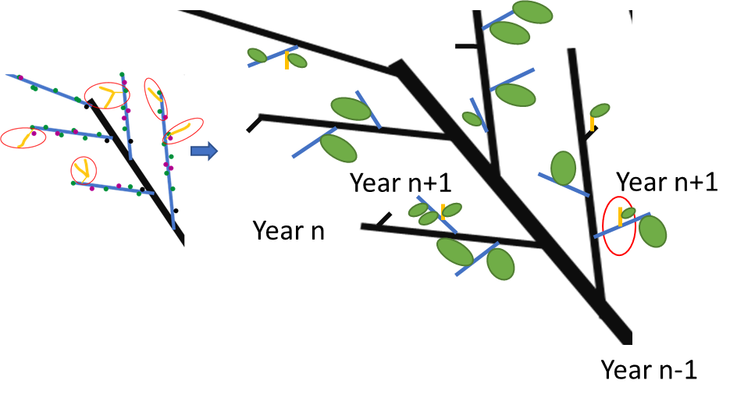In year *n+1*, at each metamer of the **parent shoot** (annual shoot), at least one **lateral shoot** (Fig. 5). They can develop **from vegetive buds and/or mixed lateral buds** that were in proleptic or sylleptic shoots (Fig. 5) The lateral shoots were also classified using the same four length class used for parent annual shoots and the same biometrical and bud fate measurements were recorded(Table1a).

Fig. 5: Lateral child (right side) developed from mixed and/or vegetative lateral buds in year n+1. They could develop directly from buds in the proleptic shoot (blue lines on the left side) or buds of sylleptic shoots (yellow line on the left side).

Laterals could also be proleptic (blu lines on the right side of Fig. 4) or sylleptic (yellow lines on the right side in Fig. 4) if they have catkins (Fig. 6).

Fig. 6: lateral sylleptic shoots (bears catkins) grown in the same year of proleptic.

|  |  |
| --- | --- |
| **Description of lateral shoot** | |
| TOTAL number of lateral shoots (year n+1) | 886 |
| How many parents have at least 1 lateral child? | 99 |
| How many buds lateral buds are in the parental shoot? | 1594 (843 in Proleptic, 751 in Sylleptic) |

Table3: an overview of lateral shoot data

Question3: how many parents have at least 1 lateral child? 99

Question4: What were the length class of those parents? 28LO, 25Me, 21Sh, 25VLo

Question5: What is the length class of new shoots? 3Lo, 63Me, 818Sh

Question 6: how many new shoots from sylleptic and how many from proleptic? 303 from buds in Sylleptic and 582 from buds in proleptic

Question 7: how many M+V laterals are from sylleptic and from proleptic? 522 in Syl and 698 in Prol

Question 8: what is the % of V and M buds developed in sylleptic and in proleptic? 50% in Syl and 80% in Prol

Question 9: How many shoots developed from B or C (errors)? 5.08%

Question 10: what is the relationship between the length of parents (PROLEPTIC) and length of lateral? I chose the proleptic because I don’t know the length of sylleptic and I do not know the rank nodes of sylleptic

Fig. 7: percentage of lateral child (from buds in PROLEPTIC) class length per each parental class length

Question 11: How many buds/sylleptic are on average in the proleptic parental shoot? Whatever their length?

Fig. 8:a(left) percentage of lateral buds/sylleptic whatever parental length (not counting buds INSIDE the sylleptic); b(right) percentage of buds(v&m) in sylleptic shoots (counting just buds in sylleptic shoots).

Question 12: how are lateral buds/sylleptic distributed along with the different length classes of the proleptic parental shoot?

Fig. 9 percentage of lateral buds/sylleptic per each parental class length (not counting buds INSIDE the sylleptic)

Fig. 10 numbers of lateral buds/sylleptic per each parental class length not counting buds INSIDE the sylleptic)

Question 13: what is the distribution, among the ranks, off lateral buds/sylleptic in proleptic parental?

Fig.11: distribution of lateral buds/sylleptic along annual shoots rank nodes whatever the parental class length. (using data of proleptic parental shoot). In this graph, rank nodes less frequent (>18) are excluded.

it seems that from nodes 5 to 10 there is a pick of sylleptic, mixed, and vegetative buds. These are the only ones that, after node 10, remain constant along with rank nodes and then increase. Mixed and vegetative are **complementary**. This graph is made considering all the class lengths of the parent shoots.

in some rank nodes, in proleptic shoots, there can be **more than one bud.**

Question 14: what is the number of buds, per rank node, in proleptic shoots?

Fig.12 a(left): number of buds/sylleptic, per rank in proleptic shoots (NB. NB. Sylleptic and their buds are counted as 1).). b(right) percentage of buds/sylleptic per rank, in proleptic shoots (percentage computed per each rank).

**In proleptic shoots, the majority of ranks have 1 bud/sylleptic (red columns) while few nodes have multiple buds.**

Question 15: what is their composition? per rank node, in proleptic shoots?

Fig.13 a(left): number of combinations of buds/sylleptic, per rank in proleptic shoots (NB. Sylleptic and their buds are counted as 1). b(right) percentage of combinations of buds/sylleptic per rank, in proleptic shoots (percentage computed per each rank).

**Sylleptic are more in the middle (node 4-7) of proleptic (parental) shoots. it seems we can highlight different zones: the first one (node 1-4) with the majority of B and V. the second (node 4-7) with more variability (more sylleptic shoots and more multiple buds), the third one (7-11) with a prevalence of mixed and the fourth one (11-17) with a prevalence of vegetative and few multiple (vegetative+vegetative). This is in accordance also with fig. 11.**

Question 16: what is the variability in sylleptic shoots?

Fig.14 a(left): number of buds in sylleptic, per rank of proleptic shoots. b(right) percentage of buds in sylleptic, per rank of proleptic shoots (percentage computed per each rank).

**The variability is more around nodes 4-7 because there are more sylleptic (fig13b)!!! We do not have the info regarding the rank nodes inside the sylleptic.**

Question 1 7: what is their composition? per rank node, in sylleptic shoots?

Fig.15 a(left): number of combinations of buds in sylleptic, per rank of proleptic shoots. b(right) percentage of combinations of buds in sylleptic, per rank of proleptic shoots (percentage computed per each rank).

Question 18: How many buds develop, per rank in proleptic shots?

Fig.16 a(left): number of combinations of laterals, per rank in proleptic shoots (NB. Laterals from sylleptic are NOT considered). b(right) percentage of combinations of laterals per rank, in proleptic shoots (percentage computed per each rank).

The most frequent class is 1 Short shoot. At the top of the parent shoot (greater rank node), there are more Medium shoots and a few long ones. This is **proof of acrotony. This is confirmed also by fig. 7**

Question 19: How many buds develop, per parental rank in sylleptic shots?

Fig.17 a(left): number of laterals from sylleptic buds, per rank of proleptic shoots. b(right) percentage of laterals from sylleptic buds, per rank of proleptic shoots (percentage computed per each rank).

**The variability is more around nodes 4-7 because there are more sylleptic (fig13b)!!! We do not have the info regarding the rank nodes inside the sylleptic.**

Question 20: What is the percentage of M and V buds that developed in sylleptic and proleptic shoots??

Fig. 18: percentage of V (orange) or M(purple) buds, in proleptic shoots, that developed.

The average is 80%. at the base of the shoot, nearly 40% of buds did not develop, and then this percentage increased with shoot length.

Question 21: What is the length of lateral shoots developed from M and V??

Fig. 19: (a, left)percentage of different lateral classes developed fromV. (b, right) percentage of different lateral classes developed from M in proleptic shoots.

The average is 100% of lateral shoots that developed from M buds are Sh shots almost from rank 1 to tank 15. Few Medium shoots are observed, developed from V, in medium-long shoots

Fig. 20: (a, left)numbers of different lateral classes developed fromV. (b, right) numbers of different lateral classes developed from M in proleptic shoots.

#### Apical shoot

In year *n+1* the **apical shoots** were classified according to their length (Table1a). When several buds were present in the apical position of the parent shoot, the longest was considered as the succession of the parent shoot (apical shoot) (Fig. 5).

Fig. 21: apical developed from mixed and/or vegetative apical buds in year n+1.

|  |  |
| --- | --- |
| **Description of apical shoot** | |
| TOTAL number of apical shoots (year n+1) | 104 |
| How many parents have apicals? | 104 |

Table4: an overview of apical shoot data

Question 22: what is the relationship between the length of parents (PROLEPTIC) and length of apicals?

Fig. 22: percentage of apical child class length per each parental class length

Question 23: How many buds are on average in the proleptic parental shoot? Whatever their length?

Fig. 23: percentage of apical buds whatever parental length

Question 24: how are apical buds distributed along with the different length classes of the proleptic parental shoot?

Fig. 24: percentage of apical buds per each parental class length Chart, bar chart

Description automatically generated

### Glms/Markovian

### FSPM

We agree that a piece of information is missing in my data: **distribution of length in the three.** I have the information on how buds (lateral and apical) develop, where they are. But I do not know where the parental shoots were in the three.  
The solution is two:

1. 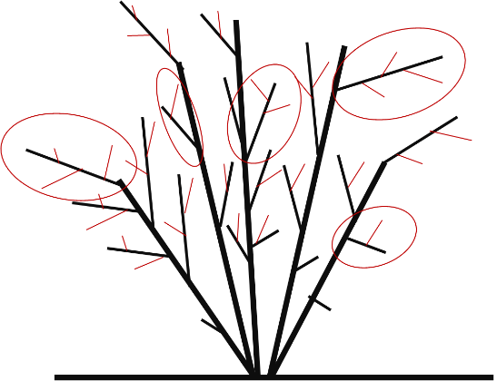Thake 10 2years old shoots and make biometric measures (rank node, number of nodes, length, diameter) of all lateral and apical shoots.
2. 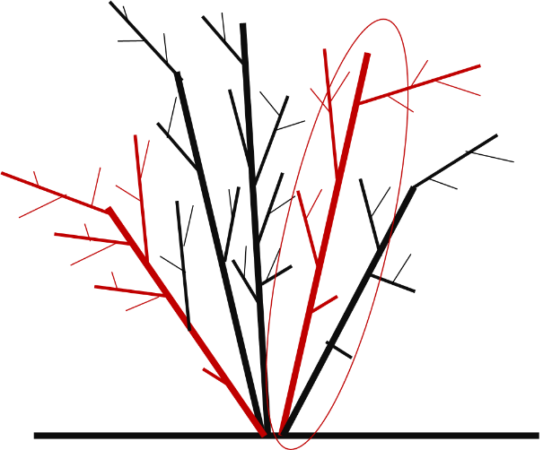Thake 10 main branches and take biometric measurements of all the shoots in that plant (age of the shoot, order, rank node, number of nodes, length, diameter).